Terms and Conditions
You agree to the terms and conditions outlined here with respect to the site. This supersedes any and understanding, representations, and warranties expressed or implied. And may be changed as TSA deems fit without notification. You as the purchaser assume all responsibility for the purchase, end use, compatibility, or suitability for your intended purpose. TSA assumes no legal, or financial responsibility of any kind for any reason. No warranty is offered or expressed.
We accept no liability for damages caused by viruses that are contained within the electronic communications or use of our site. The use of linked sites or third-party affiliations or data posted from outside sources – the site user or other, expressly holds TSA harmless from any and all potential damages and infringements.
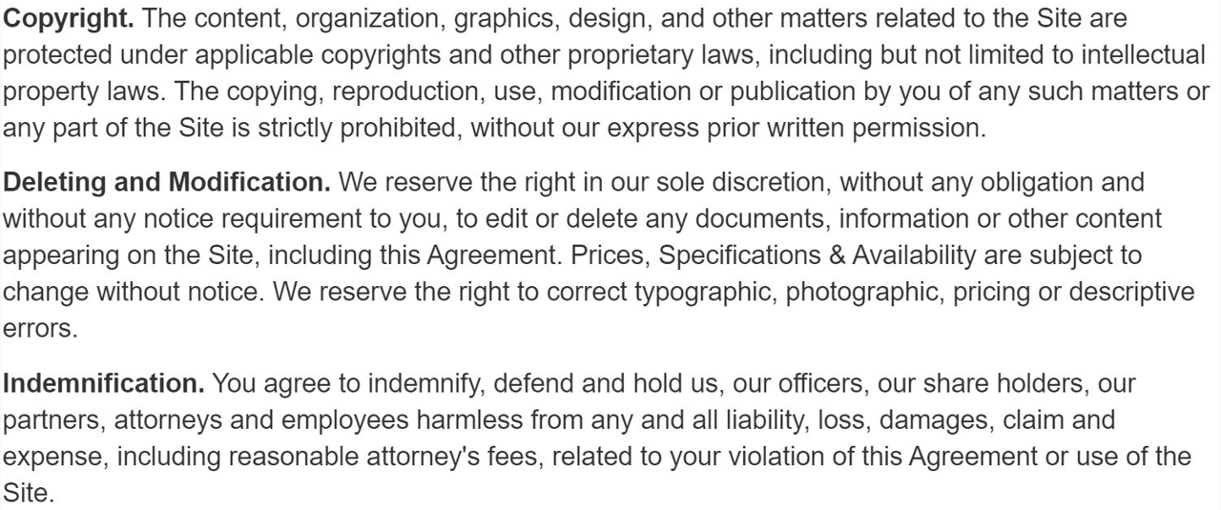As the recipient of any item a free item or purchased from this site you fully agree to accept all responsibility to include any applicable laws governing its use or ownership. Tsa is not an enforcement agency to police you or your actions. You agree by receiving any product by any means from this site to hold Tsa, its owners, officers, shareholders, principals harmless.
No Items on this site require the use of Federal Firearms License. However, some items may require compliance to other laws or regulations. You are responsible for this knowledge and agree that you are alone responsible for your purchase and actions.
The act of receiving any product purchased or not, guarantees your agreement to these terms and conditions.

